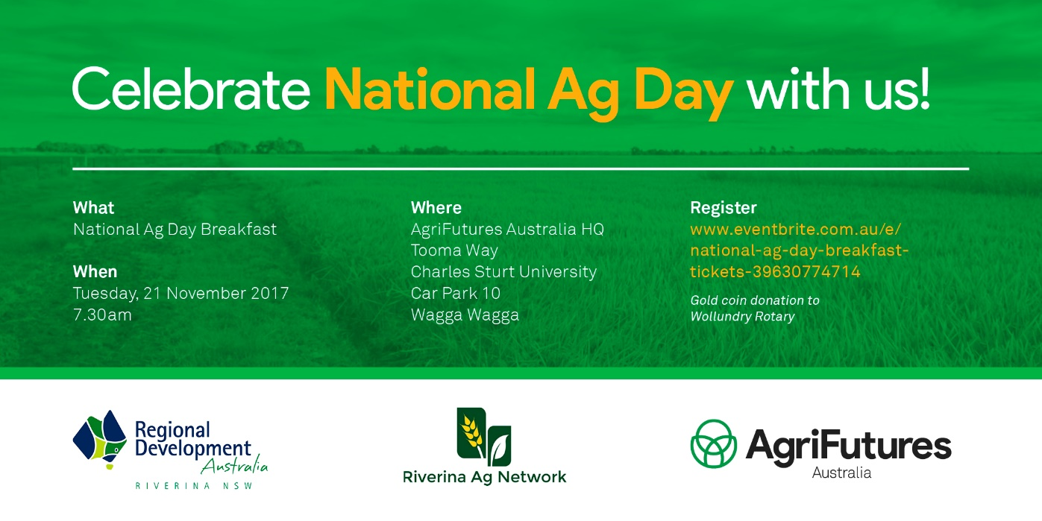 National Ag Day Breakfast
On the 21st November RDA Riverina in conjunction with AgriFutures Australia and Riverina Ag Network hosted a National Ag Day breakfast. This was the first for a cornerstone event in our region.
With Agriculture generating $2,313.673 M in revenue to the Riverina, RDA Riverina believe it should be supported and celebrated.
We were joined from 7.30am at the AgriFutures verandah and lawn at CSU Wagga campus with 60 people to enjoy local, eggs, bacon, orange juice, water and coffee from Cackleberries Eggs, Wagga Wagga Free Range Pork - Berkshire Pigs, AusGrown Orange Juice, and Big Springs Water.
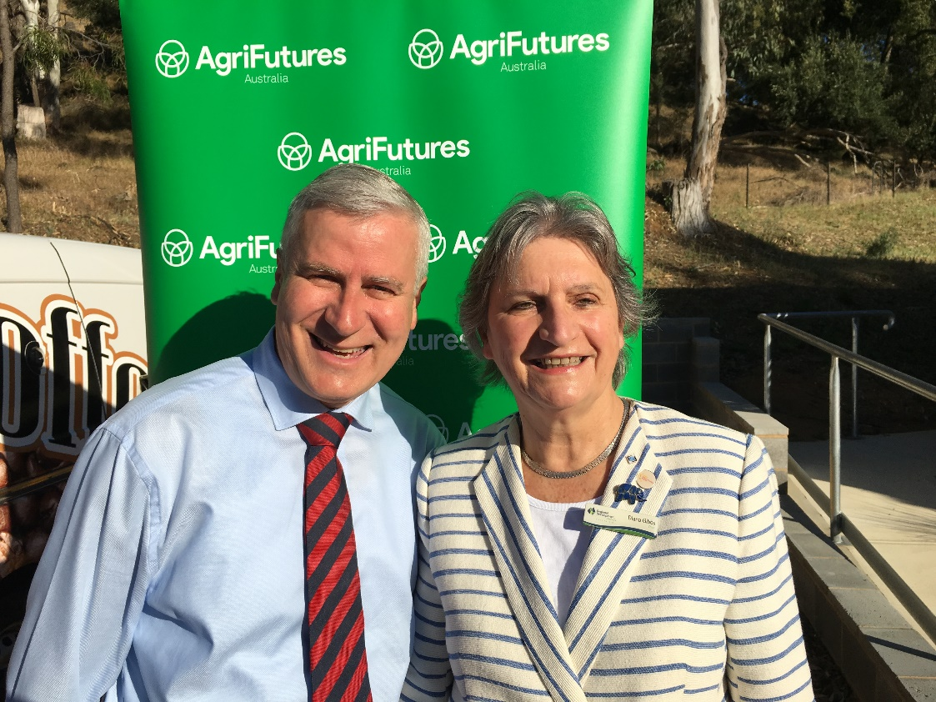
Thanks also to Wollundry Rotary for manning the BBQ. The event asked for a gold coin donation and a total of $136.40 was raised with the funds going to a Rotary Health project “Lift The Lid On Mental Illness.”
Member for Riverina Michael McCormack and RDA Riverina Chair Diana Gibbs at the Wagga National Ag Day Breakfast

