Morning Tea with Tanya Dupagne

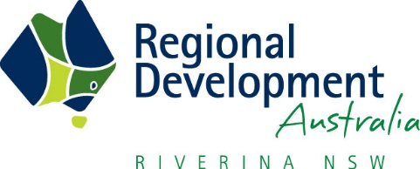
Last week RDA Riverina were privileged to host Tanya Dupagne, 2017 AgriFutures™ Rural Women’s Award National Winner, as our guest speaker. Tanya spoke about her program Camp Kulin, what it is like to be a ‘Country Changer’ and the Rural Women’s Award leadership opportunities. It was a lovely morning tea. Thank you to everyone who joined us.
If you’d like to learn more about Tanya and her Camp Kulin projects and programs or other state winners check out the link below.
http://www.agrifutures.com.au/people-leadership/rural-womens-award/current-winners/

