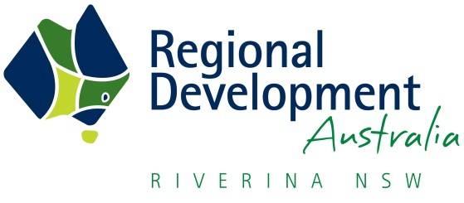 | Project Proposal Outline Form  for  RDA Riverina
Title of the Project Proposal:
Project Champion ( who is driving the project or is accountable for its delivery)
Contact for the project:
Name:
Organisation:
Email:
Ph:

List the Local Government Area (LGA)/s & RDA/s where the project is located.

Rationale or need for the project. Provide evidence if possible:-
Project Description:
What has been committed or what is the progress to date:
Project Budget: (What is the budget for the project and who is contributing (cash or in-kind) to the project)

Contributer: Government, NGO, private enterprise | Description of project activity or stage | Cash Contribution | In-Kind Contribution
Total

What is the timeline for the project?

What are the key outcomes of the project? How will you measure and evaluate the project? (use merit criteria: economic benefit; social benefit; value for money; project delivery)
What are the project risks and mitigation strategies?
Demonstrate how you think your project proposal aligns with the RDA-Riverina Regional Plan/ State Plan?
What is required for the project to be completed? Feasibility study, letter of support, funding, development applications, private business investment, stakeholder engagement etc.
The information provided in this document will be important when seeking support (financial or otherwise) for your project. Please return this completed form via email to Rachel Whiting (Chief Executive Officer and Director of Regional Development) ceo@rdariverina.org.au or Marg Couch (Project Officer) po@rdariverina.org.au

