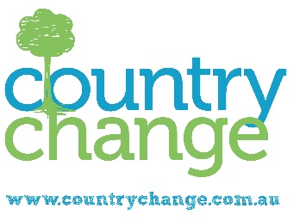
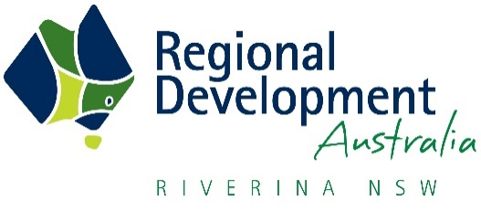

FAMILIES MAKE A COUNTRY CHANGE

When Andre and Keryl De Hann moved to Coolamon with their young family, it was a big change from the lives they had in Sydney – and they couldn’t be happier.
Andre and Keryl, owners of Sweet Briar B&B, share their story as part of a new campaign promoting the Riverina as the ideal place to make a Country Change.
“We came to Coolamon to visit a friend and moved here. We accidentally walked into Sweet Briar and we just jumped in boots and all,” Andre said.
“Coolamon is a great place. We get to be a lot more involved in the boys’ lives and it’s just been easier to connect in everyday life. It’s not separate; I’m not going off to work and only seeing them in the evening.”
An initiative of Regional Development Australia (RDA) Riverina, the Country Change campaign is jointly funded by RDA partnering with 10 regional councils and is supported by the NSW State Government’s Regional Growth – Marketing and Promotion Fund.
As RDA Riverina Director of Regional Development and CEO Rachel Whiting explains, the campaign is designed to increase investment in the Riverina by attracting new residents and businesses.
“Through Country Change, we are strategically marketing the Riverina as a place to live, work and invest, and with the average regional house price being around $300,000 less than the average capital city price, a country change makes affordable sense.
“The campaign includes promotions in metropolitan areas, such as Sydney, Canberra and Melbourne, development of a Riverina Investment Prospectus and refreshing the Country Change website (www.countrychange.com.au). We also hosted a two-day Country Change Expo in Temora last year to showcase the area to those considering making the move.
“We are delighted with the interest shown in the Riverina. Since the campaign began in August, we’ve reached more than 200,000 people, had more than 150,000 video views on Facebook and had 40 families register for the Country Change Expo in Temora.”
Ms Whiting believes attracting people to the Riverina is a vital step in ensuring a prosperous region into the future.
“In 2011-2016, we had a 0.5% population increase. By 2036, we expect that population growth to increase by 14.5%, or around 25,000 people, to reach more than 200,000 residents region-wide.
“The big driver of this accelerated rate of growth is agriculture, with the introduction and expansion of many agricultural industries and value-adding operations, as well as the support services that go hand-in-hand with population growth.
“For our communities to thrive, we have to be able to attract people to the region and we know that agriculture will play a big part in this into the future.
“Through the Country Change campaign, we looking to open people’s eyes to the opportunities that exist not only within the agriculture but across all industries and our many vibrant communities.”
For those considering the move, Keryl De Hann’s advice is clear.
“You gain so much. It’s worth giving it a go – take the plunge!”

- Ends -

MEDIA NOTE: Watch the De Hann’s story here.

For more information, contact RDA Riverina Director of Regional Development and CEO Rachel Whiting on 0429 444 213.

Local Government Areas supporting the Country Change campaign include:

- Coolamon Shire Council
- Cootamundra-Gundagai Regional Council
- Junee Shire Council
- Lockhart Shire Council
- Murrumbidgee Council
- Snowy Valleys Council
- Temora Shire Council
- Greater Hume Council
- Griffith City Council
- Narrandera Shire Council

